### MINOR PROJECT REPORT

On

### *“*AI-based mobile App for predicting high risk skin abnormalities from photographic images*”*

*Submitted in partial fulfillment of the requirements for the award of*

### Bachelor of Technology (B.Tech)

In the department of

### Computer Science & Engineering

### 

*Submitted by*:

### Soumik Das (UG/02/BTCSE/2020/040)

*Under the Guidance of*

### Dr. Jhilam Mukherjee

### Assistant Professor

### Dept. Of CSE

### Adamas University

**School of Engineering & Technology**

**ADAMAS University, Kolkata, West Bengal**

**Jul 2023 – Dec 2023**

**CERTIFICATE**

This is to certify that the project report entitled ***“*AI-based mobile App for predicting high risk skin abnormalities from photographic images*”****,* submitted to the School of Engineering & Technology (SOET), **ADAMAS UNIVERSITY, KOLKATA** in partial fulfillment for the completion of **Semester – 7th** of the degree of **Bachelor of Technology** in the department of **Computer Science & Engineering**, is a record of bonafide work carried out by **Soumik Das**, **UG/02/BTCSE/2020/040.,** under our guidance.

All help received by us from various sources have been duly acknowledged.

No part of this report has been submitted elsewhere for award of any other degree.

**________________________**

**Dr. Jhilam Mukherjee**

**(Project Guide)**

**______________________**

**Mr. Sayantan Singha Roy / Mr. Aninda Kundu**

**(Project Coordinator)**

**_____________________**

**Dr. Sajal Saha**

**(HOD CSE)**

### ACKNOWLEDGEMENT

The satisfaction and euphoria that accompany the successful completion of any task would be incomplete without the mentioning of the people whose constant guidance and encouragement made it possible. I take pleasure in presenting before you, my project, which is the result of a studied blend of both research and knowledge.

I express my earnest gratitude to our **Dr.Jhilam Mukherjee (Project Guide)**, **Department of CSE**, for their constant support, encouragement and guidance. I am grateful for their cooperation and valuable suggestions.

Finally, I express my gratitude to all other members who are involved either directly or indirectly for the completion of this project.

## DECLARATION

I, the undersigned, declare that the project entitled ‘AI-based mobile App for predicting high risk skin abnormalities from photographic images’, being submitted in partial fulfillment for the award of Bachelor of Engineering Degree in Computer Science & Engineering, affiliated to ADAMAS University, is the work carried out by me.

_____________________

**Soumik Das**

**(UG/02/BTCSE/2020/040)**

**ABSTRACT**

Skin cancer is a significant global health concern, and early detection plays a crucial role in improving outcomes for affected individuals. This abstract presents an innovative AI-based mobile application designed for predicting high-risk skin abnormalities through the analysis of photographic images. The proposed solution leverages advanced deep learning algorithms to enhance the accuracy and efficiency of skin cancer risk assessment.

The mobile app integrates a user-friendly interface that allows individuals to capture high-resolution images of their skin lesions using the device's camera. These images are then processed through a deep learning model trained on a diverse dataset of skin abnormalities, including various types of melanomas and other high-risk lesions. The model utilizes convolutional neural networks (CNNs) to extract intricate patterns and features from the images, enabling it to identify potential indicators of malignancy.

This AI-driven mobile app holds the potential to revolutionize skin cancer screening by providing a convenient, accessible, and efficient tool for early detection. By leveraging the power of artificial intelligence, it aims to empower users in monitoring their skin health and facilitates timely interventions, ultimately contributing to improved outcomes in the fight against skin cancer.

**TABLE OF CONTENTS**

|  |  |  |
| --- | --- | --- |
| **CHAPTER** | **TITLE** | **PAGE** |
|  | **TITLE PAGE** | i |
|  | **CERTIFICATE** | ii |
|  | **ACKNOWLEDGEMENT** | iii |
|  | **DECLARATION** | iv |
|  | **ABSTRACT** | v |
|  | **TABLE OF CONTENTS** | vi |
|  | **LIST OF FIGURES** | ix |
|  | **LIST OF TABLES** | x |
| **1** | **INTRODUCTION** | 1-3 |
|  | 1.1 Background | 1 |
|  | 1.2 Purpose of the project | 2 |
|  | 1.3 Problem Statement | 2 |
|  | 1.4 Objective | 3 |
|  | 1.5 Structure of project | 3 |
| **2** | **LITERATURE REVIEW** | 4-10 |
|  | 2.1 Literature review of some of the previous reports | 4 |
| **3** | **TECHNOLOGY** | 11-16 |
|  | **3.1 Data Augmentation Technique** | 11 |
|  | **3.2 CNN Architecture** | 11 |
|  | 3.3 Confusion Matrix | 13 |
|  | 3.4 Performance Matrices | 14 |
|  | 3.4.1 Accuracy | 14 |
|  | 3.4.2 Specificity | 15 |
|  | 3.4.3 Sensitivity | 15 |
|  | 3.4.4 ROC Curve | 15 |
| **4** | **METHEDOLOGY** | 17-19 |
|  | 4.1 Data Collection | 17 |
|  | 4.2 Data Augmentation | 18 |
|  | 4.3 Model Implementation | 19 |
| **5** | **OUTPUT** | 20-24 |
|  | 5.1 Performance Analysis | 20 |
|  | 5.2 Visual verification of the predicted results | 23 |
|  | **CONCLUSION** | 25 |
|  | **FUTURE WORK** | 26 |
|  | **REFERENCE** | 27 |
|  | **PLAGARISM REPORT** | 29 |

**LIST OF FIGURES**

|  |  |  |
| --- | --- | --- |
| **FIGURE** | **TITLE** | **PAGE** |
| Fig 1.1 | Early Sign of Skin Cancer | 2 |
| Fig 2.1 | Melanoma Skin Cancer | 5 |
| Fig 2.2 | Basal Cell Carcinoma | 5 |
| Fig 2.3 | Squamous Cell Carcinoma | 6 |
| Fig 3.1 | CNN Architecture | 13 |
| Fig 3.2 | Confusion Matrix Diagram | 14 |
| Fig 4.1 | Benign Image | 17 |
| Fig 4.2 | Malignant Image | 17 |
| Fig 4.3 | Augmented Images | 18 |
| Fig 4.4 | Block Diagram of the Model | 19 |
| Fig 5.1 | Epoch vs Accuracy Graph on 80/20 Dataset | 21 |
| Fig 5.2 | Confusion Matrix of 80/20 Dataset at epoch 90 | 22 |
| Fig 5.3 | ROC Curve of 80/20 Dataset at epoch 90 | 22 |
| Fig 5.4 | Visual verification of the predicted results | 23-24 |

**LIST OF TABLES**

|  |  |  |
| --- | --- | --- |
| **FIGURE** | **TITLE** | **PAGE** |
| Table 5.1 | Output results on different Datasets graph at epoch 90 | 20 |
| Table 5.2 | Accuracy of 80/20 Dataset at different epochs | 21 |

**CHAPTER 1**

**INTRODUCTION**

**1.1 Background:**

Skin cancer, including malignant melanoma, poses a significant global health challenge, underscoring the critical importance of early detection for improved patient outcomes. In response to this pressing need, this introduction presents an innovative AI-based mobile application designed to predict high-risk skin abnormalities from photographic images, classifying them into two distinct categories: benign and malignant. Harnessing the power of artificial intelligence, this mobile app aims to revolutionize the landscape of skin health monitoring by providing users with a sophisticated tool for self-assessment, timely intervention, and a more nuanced understanding of potential risks associated with their skin lesions.

Skin cancer, particularly malignant melanoma, is characterized by subtle changes in the appearance of moles and lesions, making early detection challenging. The proposed mobile app seeks to address this challenge by incorporating advanced deep learning algorithms, specifically designed for binary classification into benign and malignant classes. Users will be able to capture high-resolution images of their skin lesions using the mobile app, which will then undergo real-time analysis utilizing a deep learning model trained on a diverse dataset encompassing both benign and malignant skin abnormalities.

The user-friendly interface of the app not only facilitates seamless image capture but also provides users with prompt risk assessments, categorizing identified abnormalities based on their malignant potential. This two-class classification system aims to offer a more nuanced and actionable understanding of skin health, empowering users to make informed decisions about seeking professional medical advice and intervention.

In the subsequent sections, we will delve into the key features of this AI-driven mobile app, emphasizing its potential to contribute significantly to the early detection of malignant skin abnormalities. By bridging the gap between technological innovation and skin health awareness, the app strives to empower users in their proactive management of skin conditions and, ultimately, contribute to the global efforts in combating skin cancer. Early sign of the skin cancer is shown in Fig 1.1

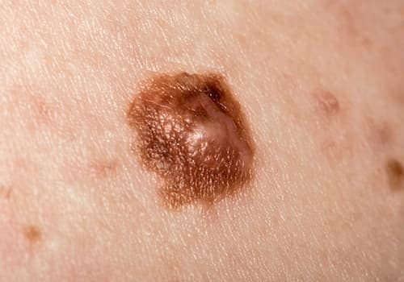

Fig 1.1: Early Sign of Skin Cancer

**1.2 Purpose of the project:**

The purpose of the AI-based Mobile App for Predicting High-Risk Skin Abnormalities is to democratize and enhance dermatological care through the integration of artificial intelligence and mobile technology. This innovative application aims to empower individuals to take proactive control of their skin health by enabling self-assessment and early detection of high-risk abnormalities through the analysis of photographic images. By leveraging advanced AI algorithms, the app provides personalized risk assessments, fostering timely intervention and preventive measures. The project addresses the critical need for continuous monitoring and accessibility in dermatological care, offering a user-friendly platform that promotes regular self-assessment, education, and notification-driven vigilance. Ultimately, the purpose is to revolutionize the paradigm of skin health management, contributing to early intervention, improved outcomes, and a more engaged and informed user base.

**1.3 Problem Statement:**

The existing approach to skin health monitoring often relies on periodic clinical assessments, creating a significant gap in continuous, accessible, and proactive care. Limited access to dermatological expertise, coupled with delayed detection, poses a serious challenge to the early identification of high-risk skin abnormalities. Traditional methods also lack a user-friendly and scalable solution for regular self-assessment. This project addresses these challenges by developing an AI-based Mobile App for Predicting High-Risk Skin Abnormalities. The problem lies in the absence of a convenient, personalized, and technologically advanced tool that empowers individuals to monitor their skin health autonomously. The goal is to bridge this gap, enabling early detection through the analysis of photographic images, personalized risk assessments, and timely notifications, thereby revolutionizing the landscape of dermatological care.

**1.4 Objective:**

### The primary objective of the AI-based mobile app is to revolutionize skin health monitoring by leveraging advanced artificial intelligence algorithms for the accurate prediction of high-risk skin abnormalities from photographic images. This entails developing a user-friendly interface that enables individuals to effortlessly capture and upload high-resolution skin images for real-time analysis. The app aims to provide immediate risk assessments, categorizing identified abnormalities into different risk levels, and facilitating seamless integration with dermatology services for further evaluation. By implementing a continual learning mechanism, the app strives to enhance its diagnostic accuracy over time, while also promoting skin health awareness through educational features.The overall goal is to make early detection and intervention for high-risk skin conditions more accessible, efficient, and globally impactful.

### 1.5 Structure of the Project:

### The project focuses on the development of a deep learning model for predicting high-risk skin abnormalities from photographic images with classes "low risk" and "high risk." The primary components include the implementation of Convolutional Neural Network (CNN) architecture, specifically tailored for image classification tasks. The project begins with an introduction, emphasizing the significance of early detection in dermatology. Following this, a literature review explores existing methodologies and studies related to skin cancer diagnosis using deep learning. Data collection involves the acquisition of a labeled dataset, with subsequent preprocessing steps ensuring uniformity and quality. The CNN model, pivotal to the project's success, is carefully designed, integrating convolutional and dense layers with appropriate activation functions. Data augmentation techniques are employed to enhance the model's robustness and generalization capabilities. The training process involves splitting the dataset, selecting optimal hyper parameters, and evaluating model performance. The results presented quantitatively and visually, are followed by an analysis of interpretability and clinical relevance. Deployment considerations encompass the integration of the model into a mobile app, ensuring user-friendly interfaces. The project concludes with ethical considerations, implications, and avenues for future research. The structure aligns with a coherent and systematic approach to developing an effective deep learning model for skin abnormality prediction, merging advancements in CNN architectures with essential data augmentation strategies.

**CHAPTER 2**

**LITERATURE REVIEW**

**2.1 Literature review of some of the previous reports:**

Skin cancer is a type of cancer that originates in the skin cells. It is characterized by the uncontrolled growth of abnormal skin cells, typically triggered by damage to the DNA of skin cells, often caused by exposure to ultraviolet (UV) radiation from the sun or artificial sources like tanning beds.

There are several types of skin cancer, categorized based on the cells from which they originate. The two main types are melanoma and non-melanoma skin cancers, which include basal cell carcinoma (BCC) and squamous cell carcinoma (SCC).

1. **Melanoma:** Melanoma develops in the melanocytes, the pigment-producing cells responsible for melanin production. It is less common than non-melanoma skin cancers but has a higher potential to metastasize (spread) to other parts of the body. Melanomas often appear as asymmetrical moles with irregular borders, varied colors, and a larger diameter referred to Fig 2.1.

**Symptoms:** Melanoma, a type of skin cancer, may exhibit signs following rule: asymmetry, irregular borders, uneven coloring, a diameter larger than a pencil eraser, and evolution (changes in size, shape, color, or elevation). It is crucial to be attentive to moles or lesions that differ significantly from others, known as the "ugly duckling" sign. Melanomas can also present with itching, tenderness, or ulceration, where the lesion breaks through the skin, forming an open sore that may bleed. Early detection is essential for successful treatment, and any suspicious changes in the skin should prompt immediate consultation with a healthcare professional, particularly a dermatologist. Regular skin self-exams and professional skin checks are advised, especially for those with risk factors for skin cancer.

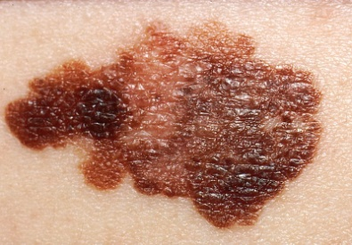

Fig 2.1: Melanoma Skin Cancer

**2. Non-Melanoma Skin Cancers:**

* **Basal Cell Carcinoma (BCC):** BCC is the most common type of skin cancer. It tends to grow slowly and is usually localized, with a low risk of spreading to other parts of the body. BCC often appears as a pearly or waxy bump, or a flat, flesh-colored or brown scar-like lesion. Fig 2.2 referred to the Basal Cell Carcinoma.

**Symptoms:** Basal Cell Carcinoma (BCC), the most prevalent form of skin cancer, typically manifests as a slow-growing, shiny or pearly bump, nodule, or growth on sun-exposed areas like the face, head, and neck. The lesion may develop a central ulcer, crust over, bleed easily, or resemble a scar-like or reddish patch on the skin. Some BCCs have a waxy or translucent appearance. While these tumors rarely metastasize, they can invade surrounding tissues if untreated. Early signs often include changes in skin texture, ulceration, and a slow, painless growth. If any of these symptoms are observed, it is crucial to seek prompt medical evaluation, preferably from a dermatologist, for accurate diagnosis and appropriate management. Regular skin self-exams and professional skin checks are recommended for early detection and treatment.

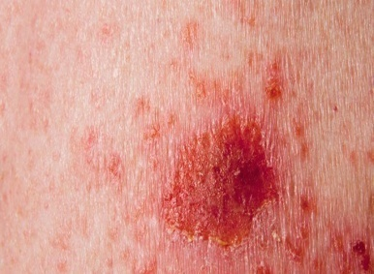

Fig 2.2: Basal Cell Carcinoma

* **Squamous Cell Carcinoma (SCC):** SCC arises in the squamous cells, which are found in the outer layer of the skin. It can metastasize, although less commonly than melanoma, and is associated with a higher risk of spreading than basal cell carcinoma. SCC may appear as a red, scaly patch, an open sore, or a raised growth with a central depression referred to Fig 2.3.

**Symptoms:**Squamous Cell Carcinoma (SCC), a common form of skin cancer, typically presents as a raised, red, scaly patch, a firm and nodular lesion, or an open sore that may crust or bleed. Developing in the squamous cells of the skin, SCC often occurs in sun-exposed areas and can be associated with a history of chronic sun exposure or pre-existing skin conditions. Unlike basal cell carcinoma, SCC has a higher potential to metastasize, although it generally does so less frequently than melanoma. Early symptoms may include changes in the skin, such as the appearance of a persistent sore, rough or scaly growth, or changes in an existing lesion. Any suspicious skin changes should be promptly evaluated by a healthcare professional, preferably a dermatologist, for accurate diagnosis and appropriate treatment. Regular skin self-exams and professional skin checks are important for early detection and management of squamous cell carcinoma.

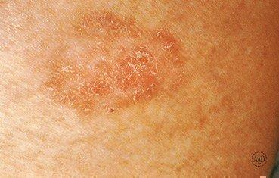

Fig 2.3: Squamous Cell Carcinoma

Apart from these main types, other, less common types of skin cancer include Merkel cell carcinoma, dermatofibrosarcoma protuberans, and cutaneous T-cell lymphoma.

It's important to note that early detection is crucial for effective treatment, and any suspicious changes in the skin should be promptly examined by a healthcare professional. Regular skin self-examinations and professional skin checks are recommended, especially for individuals at a higher risk due to factors such as sun exposure, fair skin, or a family history of skin cancer.

As the skin is the body’s largest organ, the point of considering skin cancer as the most common type of cancer among humans is understandable.The critical factor in skin cancer treatment is early diagnosis only. So for the early diagnosis various machine learning and deep learning approaches have been used for computer-based skin cancer detection in recent years.

In paper [1] Automatic detection of skin lesion with ABCD rule, GLCM and HOG are implemented and for the feature extraction and classification different machine learning approaches like SVM, KNN and Naïve Bayes classifier are used to classify skin lesion between benign and melanoma. The classification result obtained is 97.8 % of Accuracy and 0.94 Area under Curve using SVM classifiers. And additionally the Sensitivity obtained was 86.2 % and Specificity obtained was 85 % using KNN.

In paper [2] seven classes of skin lesions have been classified using Resnet-50, VGG-16, Densenet, Mobilenet, Inceptionv3, Xception, and CNN. Finally, the performance of the models is evaluated using evaluation metrics such as precision, recall, f1-score, and accuracy. Among all the models, Inceptionv3 provides the best result, which is 90 % accuracy.

In paper [3] authors propose CNN model with some image pre-processing steps that help to categorize skin lesions with a better classification rate than other existing models. Normalization, data reduction, and data augmentation are used in pre-processing steps to classify benign and malignant cancer lesions from the HAM10000 dataset. From the experimental result, the proposed model gained an accuracy of 96.10% in training and 90.93% during testing. This model reduces the execution time and also performing well-handled.

In paper [4] authors proposed the classification approach for the skin cancer images using different algorithms like VGG16, ResNet, InceptionV3 with the core methodology to modify the input images using the GAN concept of image super resolution and then passing the images in the neural network. They also provided a Residual Dense Network approach for improving the input image resolution, where the basic build component is the residual dense block (RDB). Dense connections between layers in each RDB enable maximum utilization of local layers. A dense residual network completes the simple build module for the ISR. Then the RDN permits the local layers for dense connection among different layers. The global feature fusion methodology is proposed for extracting the hierarchical features. Moreover, the proposed methodology enhances the initial accuracy by 15.59% for VGG16, 13.85% for ResNet and 7.78% for InceptionV3. Thorough benchmark assessments demonstrate that our proposed approach provides dominance over state-of-the-art procedures.

In paper [5] a novel and robust skin cancer detection model was proposed based on features fusion. In the first stage, authors proposed a model that pre-processed the images using a GF filter to remove the noise from the skin images. Then, features were extracted by employing LBP for manual features extraction and Inception V3 for automatic features extraction. Aside from this, an Adam optimizer was utilized for the adjustments of the learning rate. In the end, an LSTM network was utilized on fused features for the classification of skin cancer into two classes: malignant and benign. The skin lesion DermIS dataset available on the Kaggle website, consisting of 1000 images, out of which 500 belong to the benign class and 500 to the malignant class. The proposed methodology attained 99.4% accuracy, 98.7% precision, 98.66% recall, and a 98% F-score. After evaluating the proposed model and compared the performance with existing segmentation-based and DL-based techniques. The results show that the method provided significant results compared to existing techniques.

In paper [6] Multilevel fuse feature generation using Discrete Wavelet Transform (DWT), Local Phase Quantization (LPQ), Local Binary Pattern (LBP), pre-trained DarkNet19, and DarkNet53 are utilized to generate features of the skin cancer images, top 1000 features are selected threshold value-based Neighborhood Component Analysis (NCA). The chosen top 1000 features are classified using the 10-fold cross-validation technique. Ten-fold cross-validation is used and 91.54% classification accuracy results are obtained by using the recommended pyramidal hybrid feature generator and NCA selector-based model. Further, various training and testing separation ratios (90:10, 80:20, 70:30, 60:40, 50:50) are used and the maximum classification rate is calculated as 95.74% using the 90:10 separation ratio.

In paper [7] the project was conducted with the aim of developing convolutional neural network model to diagnose and detect skin cancer from lesion images. It also explored the data augmentation technique as a preprocessing step to strengthen the classification robustness of the CNN model. The best model, namely InceptionResnet achieved an average accuracy of 91%.

In paper [8] authors proposed a system rely on the prediction of three different methods namely A convolutional neural network and two classical machine learning classifiers trained with a set of features describing the borders, texture and the color of a skin lesion. These methods are then combined to improve their performances using majority voting. The experiments have shown that using the three methods together, gives the highest accuracy level.

In paper [9] an automated skin lesion classification method is proposed. In this method, a pre-trained deep learning network and transfer learning are utilized. In addition to fine-tuning and data augmentation, the transfer learning is applied to AlexNet by replacing the last layer by a softmax to classify three different lesions (melanoma, common nevus and atypical nevus). The proposed model is trained and tested using the ph2 dataset. The well-known quantative measures, accuracy, sensitivity, specificity, and precision are used in evaluating the performance of the proposed method where the obtained values of these measures are 98.61%, 98.33%, 98.93%, and 97.73%, respectively.

In paper [10] authors proposed an intelligent skin lesion classification system. It consists of ABCD+GLRLM, LBP and HOG feature extraction, ACPSO and RCPSO feature selection, and deep and ensemble classifiers. The proposed ACPSO model employs both global search using adaptive decreasing and increasing acceleration coefficients as well as in-depth sub-dimension based local search mechanisms to attain global optima. The RCPSO model simulates mid-air hovering flight of hummingbirds, and uses the random coefficients generated by three non-linear functions to increase both intensification and diversification capabilities. Optimal hyper-parameter identification of a deep CNN network is performed using both proposed PSO models. The empirical results indicate efficiency of the proposed ACPSO and RCPSO algorithms for discriminative lesion feature selection and optimal hyperparameter identification in deep networks. Both ACPSO and RCPSO models outperform nearly all the classical methods and the state-of-the-art PSO variants, statistically. The CNN model with the identified best training configurations also outperforms the model with the default hyper-parameter settings provided by MATLAB, significantly. The experiments also indicate efficiency of different types of lesion features contributing to melanoma classification. To further evaluate model efficiency and flexibility, two UCI data sets (i.e. breast cancer and epileptic seizure) and the ALL-IDB2 microscopic image data set are also used for evaluation. The proposed models outperform all the baseline methods for feature selection and optimal hyper-parameter identification of deep networks in most of the test cases for these data sets, as ascertained by the empirical and statistical test result

In paper [11] authors present a fully automated method for segmenting the skin melanoma at its earliest stage by employing a deep-learning based approach, namely faster region-based convolutional neural networks (RCNN) along with fuzzy k-means clustering (FKM). Several clinical images are utilized to test the presented method so that it may help the dermatologist in diagnosing this life threatening disease at its earliest stage. The presented method first preprocesses the dataset images to remove the noise and illumination problems and enhance the visual information before applying the faster-RCNN to obtain the feature vector of fixed length. After that, FKM has been employed to segment the melanoma-affected portion of skin with variable size and boundaries. The performance of the presented method is evaluated on the three standard datasets, namely ISBI-2016, ISIC-2017, and PH2, and the results show that the presented method outperforms the state-of-the-art approaches. The presented method attains an average accuracy of 95.40, 93.1, and 95.6% on the ISIC-2016, ISIC-2017, and PH2 datasets, respectively, which is showing its robustness to skin lesion recognition and segmentation.

**CHAPTER 3**

**TECHNOLOGY**

**The development of a deep learning model for predicting high-risk skin abnormalities from photographic images is at the forefront of cutting-edge healthcare technology. Leveraging advancements in artificial intelligence, this model employs a sophisticated combination of technologies to analyze and interpret complex visual data. Convolutional Neural Networks (CNNs), a cornerstone in image analysis, form the architectural backbone, capable of discerning intricate patterns and features within medical images. Furthermore, data augmentation techniques enhance the model's robustness by artificially diversifying the training dataset, ensuring it can effectively adapt to the variability inherent in skin images. Ethical considerations and regulatory compliance play a pivotal role, underscoring the importance of deploying technologies that prioritize patient privacy and align with healthcare standards. As this technology advances, it holds significant promise in revolutionizing dermatological diagnostics, offering a powerful tool for early detection and intervention in high-risk skin conditions.**

**3.1 Data Augmentation Technique:**

**Data augmentation is a technique employed in machine learning, particularly in image classification tasks, to artificially increase the diversity of a training dataset by applying various transformations to the existing images. These transformations include but are not limited to rotation, scaling, flipping, zooming, and changes in brightness and contrast. By introducing these variations, data augmentation help the model generalize better to unseen data, mitigating overfitting and enhancing the robustness and effectiveness of deep learning models. In the context of predicting high-risk skin abnormalities from photographic images, data augmentation is crucial for improving the model's ability to recognize and classify diverse skin conditions, accounting for natural variations in lighting, angles, and other factors present in medical image datasets.**

**3.2 CNN Architecture:**

Convolutional Neural Networks (CNNs) are a class of deep neural networks specifically designed for image recognition and processing tasks. The architecture of a typical CNN consists of several layers that collectively enable the model to automatically learn hierarchical representations of features from input images. Here's an overview of the common layers found in a CNN architecture referred on Fig 3.1

* **Input Layer:**

Accepts the raw pixel values of an image.

* **Convolutional Layers:**

These layers use filters or kernels to convolve over the input image, capturing local patterns and features.Convolutional operations are followed by activation functions (e.g., ReLU) to introduce non-linearity.

* **Pooling Layers:**

Pooling layers (often max pooling) follow convolutional layers to down sample the spatial dimensions of the feature maps.Reducing spatial dimensions helps in retaining important information while decreasing computational complexity.

* **Flatten Layer:**

Flattens the high-dimensional feature maps into a one-dimensional vector, preparing the data for fully connected layers.

* **Fully Connected (Dense) Layers:**

These layers connect every neuron from one layer to every neuron in the next layer, enabling the network to learn global patterns and relationships.The final dense layer produces the output for classification.

* **Output Layer:**

Produces the final prediction or classification output, often using activation functions like softmax for multi-class classification or sigmoid for binary classification.

**The number of filters, kernel sizes, and other hyperparameters can be adjusted based on the specific task and dataset. More complex architectures, including pre-trained models like VGG, ResNet, or Inception, may be employed for tasks demanding deeper and more sophisticated feature extraction capabilities.**

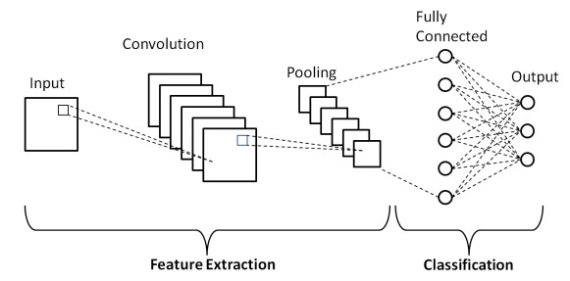

Fig 3.1: CNN Architecture

**3.3 Confusion Matrix**

**A confusion matrix is a table used in machine learning and statistics to evaluate the performance of a classification algorithm. It is particularly useful for summarizing the results of a binary classification problem, where the output can be categorized into two classes, typically labeled as positive and negative.**

**The confusion matrix organizes the model's predictions and the actual outcomes into a 2x2 matrix which is shown in Fig 3.2. The four cells of the matrix represent different scenarios:**

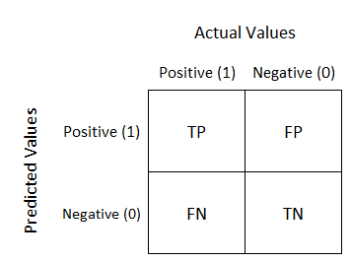

Fig 3.2: Confusion Matrix Diagram

Here's a breakdown of the elements:

* **True Positive (TP):** The instances that are actually positive and are correctly predicted as positive by the model.
* **True Negative (TN):** The instances that are actually negative and are correctly predicted as negative by the model.
* **False Positive (FP):** The instances that are actually negative but are incorrectly predicted as positive by the model. (Type I error)
* **False Negative (FN):** The instances that are actually positive but are incorrectly predicted as negative by the model. (Type II error)

**3.4 Performance Metrics:**

**3.4.1 Accuracy:**

**Accuracy, in the context of a confusion matrix, is a performance metric that assesses the overall correctness of a classification model. The confusion matrix is a table that provides a detailed breakdown of the model's predictions, distinguishing between true positive (TP), true negative (TN), false positive (FP), and false negative (FN) instances.**

**Accuracy is calculated using the following formula:**

**Accuracy = (1)**

**3.4.2 Specificity:**

**Specificity, in the context of a confusion matrix, is a performance metric that focuses on the ability of a classification model to correctly identify the true negatives (TN) out of all actual negatives. It is also known as the true negative rate or the specificity rate. The specificity is calculated using the following formula:**

**Specificity = (2)**

**3.4.3 Sensitivity:**

**Sensitivity, also known as recall or true positive rate, is a performance metric in the context of a confusion matrix that assesses a classification model's ability to correctly identify positive instances out of all actual positives. The sensitivity is calculated using the following formula:**

**Sensitivity = (3)**

**3.4.4 ROC curve**

A Receiver Operating Characteristic (ROC) curve is a graphical representation that illustrates the diagnostic ability of a binary classification model across various threshold settings. It is a common tool used in machine learning and statistics to assess the trade-off between the true positive rate (sensitivity) and false positive rate (1 - specificity).

The ROC curve is created by plotting the true positive rate (TPR) on the y-axis against the false positive rate (FPR) on the x-axis at different threshold values. Each point on the ROC curve represents a different trade-off between sensitivity and specificity. A diagonal line (the line of no-discrimination) is often used as a reference, and points above this line indicate better-than-random classification.

Key concepts related to the ROC curve:

* **True Positive Rate (Sensitivity):**

(4)

* **False Positive Rate (1 - Specificity):**

(5)

**CHAPTER 4**

**METHODOLOGY**

Developing an AI-based mobile app for predicting high-risk skin abnormalities from photographic images involves the integration of various technologies. Here are some key components and technologies commonly used for such applications:

**4.1 Data Collection:**

The dataset utilized in this project was sourced from Kaggle, a prominent platform for data science and machine learning resources. This dataset is specifically structured to facilitate the training and evaluation of the AI model for predicting high-risk skin abnormalities. The dataset comprises distinct classes of skin lesions, categorizing them into benign and malignant classes. This dichotomy enables the model to discern between non-threatening and potentially hazardous skin conditions, enhancing its diagnostic capabilities. The training subset of the dataset serves as the foundation for the model to learn the intricate patterns and features associated with benign and malignant skin abnormalities. Subsequently, the testing subset offers a rigorous evaluation framework, allowing for the assessment of the model's performance on unseen data. The inclusion of both benign and malignant classes from Kaggle ensures a comprehensive and balanced representation, fostering the development of a reliable and accurate AI-based mobile application for predicting high-risk skin abnormalities. Fig 4.1 and Fig 4.2 refers to the images contain on the dataset.

**Dataset link:** [**https://www.kaggle.com/datasets/fanconic/skin-cancer-malignant-vs-benign**](https://www.kaggle.com/datasets/fanconic/skin-cancer-malignant-vs-benign)

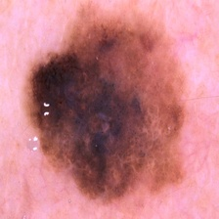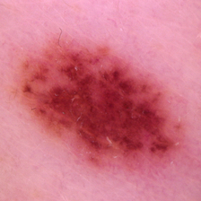

Fig 4.1: Benign ImageFig 4.2: Malignant Image

**4.2 Data Augmentation:**

Data augmentation is a critical technique employed in machine learning to enhance the diversity and quality of training datasets. In the context of developing an AI-based mobile app for predicting high-risk skin abnormalities from photographic images, data augmentation plays a pivotal role in improving the robustness and performance of the deep learning model. This process involves applying various transformations to existing images, such as rotations, flips, scaling, changes in brightness, and other distortions, thereby artificially expanding the dataset. By doing so, data augmentation addresses challenges associated with limited training data, enabling the model to learn more generalized and representative features. In the medical domain, where datasets can be scarce and imbalanced, data augmentation becomes particularly valuable. It aids in creating synthetic examples of minority classes, such as malignant skin abnormalities, contributing to a more balanced and comprehensive training set. The augmentation process not only increases the dataset size but also enhances the model's ability to handle variations in image quality, lighting conditions, and angles, ensuring improved performance and generalization when faced with diverse user-submitted images in the mobile application. After the data augmentation the total number of the images on the dataset is 17297. Examples of some augmented images are shown in Fig 4.3

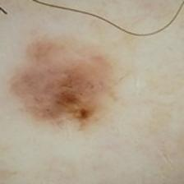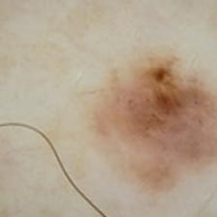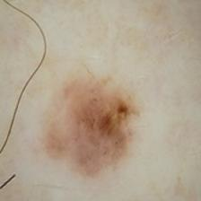

Fig 4.3: Augmented Images

**4.3 Model Implementation:**

For this project CNN is used for the model implementation. A Convolutional Neural Network (CNN) is a deep learning model specifically designed for image-related tasks. Comprising layers such as convolutional layers, pooling layers, and fully connected layers, a CNN excels at automatically learning hierarchical features from input images. The convolutional layers use filters to convolve over the input, capturing local patterns and spatial hierarchies. Pooling layers downsample the spatial dimensions, reducing computational complexity and emphasizing important features. Typically, a CNN concludes with one or more fully connected layers for classification. The model is trained through a process of forward and backward propagation, adjusting its parameters to minimize the difference between predicted and actual labels. CNNs have demonstrated remarkable success in image recognition, making them integral to various applications, including medical image analysis such as the detection of skin abnormalities in the context of dermatology applications. Fig 4.4 referred to the block diagram of the implemented model.

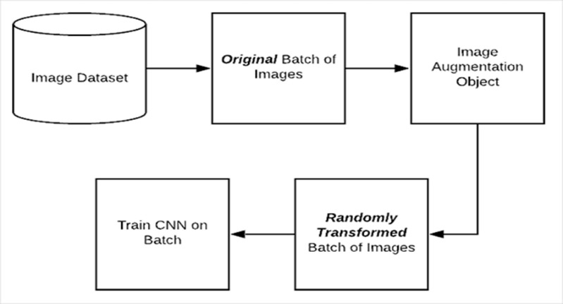

Fig 4.4: Block Diagram of the Model

**CHAPTER 5**

**OUTPUT**

This Section intends to discuss the result of the prediction model. In order to achieve the objectives of this chapter, we have executed several experiments i.e. validation of the model using 80/20, 70/30 and 60/40 training/testing proportions a 5-fold cross validation is also executed to achieve the desired accuracy of the model. Later of this chapter, we try to analysis all the results.

**5.1 Performance Analysis:**

The CNN model that is proposed gives the best result on 80/20 dataset out of all the three datasets at epoch 90.

Table 5.1: Output results on different Datasets graph at epoch 90

|  |  |  |  |
| --- | --- | --- | --- |
| **At epoch 90** | **80/20** | **70/30** | **60/40** |
| **Accuracy** | 84.19% | 62.43% | 60.89% |
| **Specificity** | 83.10% | 100% | 100% |
| **Sensitivity** | 86.22% | 1.36% | 0% |

Executing deep learning models with different training/testing proportions offers crucial advantages like preventing overfitting, tuning hyperparameters, assessing generalizability, comparing models, and addressing data imbalance. This allows us to develop a robust and reliable model with improved performance and real-world applicability.

Table 5.2: Accuracy of 80/20 Dataset at different epochs

|  |  |
| --- | --- |
| **Epoch** | **Accuracy** |
| 10 | 80.82% |
| 20 | 82.51% |
| 30 | 83.83% |
| 40 | 82.53% |
| 50 | 82.93% |
| 60 | 83.72% |
| 70 | 82.67% |
| 80 | 83.32% |
| 90 | 84.19% |
| 100 | 83.85% |

Fig 5.1: Epoch vs Accuracy Graph on 80/20 Dataset

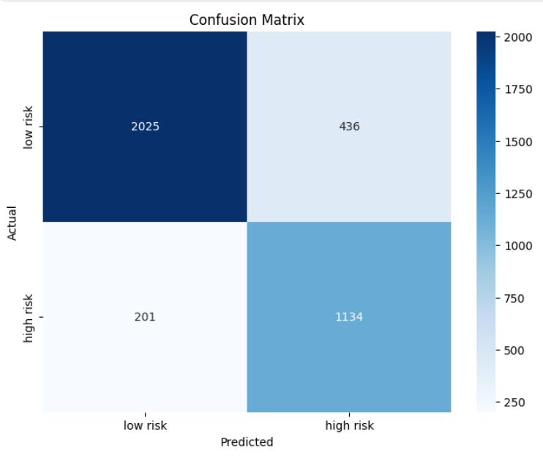

Fig 5.2: Confusion Matrix of 80/20 Dataset at epoch 90

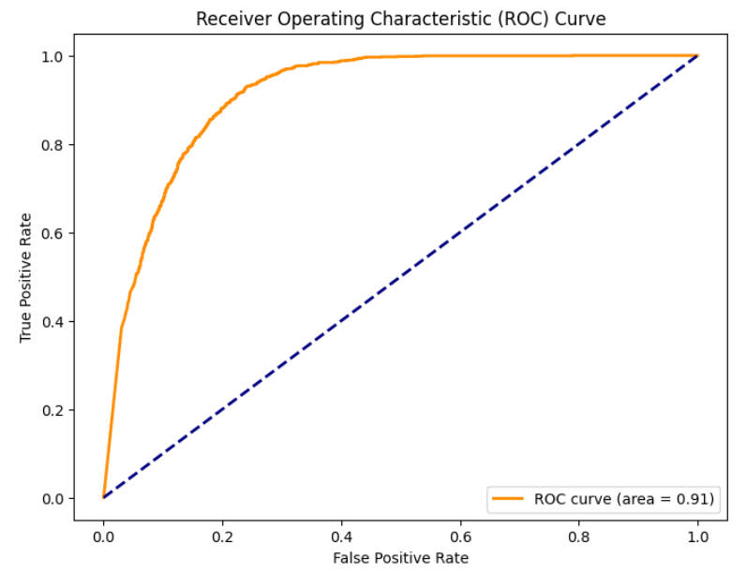

Fig 5.3: ROC Curve of 80/20 Dataset at epoch 90

A Receiver Operating Characteristic (ROC) curve with an AUC of 0.91 indicates a highly accurate classifier. This means the classifier excels at discriminating between positive and negative cases, accurately identifying both. The ROC curve itself likely exhibits a steep rise, suggesting even minor adjustments to the decision threshold can significantly enhance true positive rate while keeping false positive rate low. While such performance is already impressive, further analysis of the ROC curve and other metrics can identify areas for optimization and refine the model further.

In conclusion, an AUC of 0.91 signifies a robust classifier with exceptional discriminatory power. However, continuous evaluation and optimization remain crucial for maximizing its effectiveness in real-world applications

**5.2Visual verification of the predicted results:**

Low Risk - Negative

High Risk - Positive

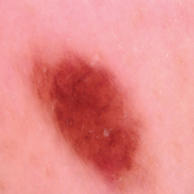

Classified

as low risk

A low risk case True Negative

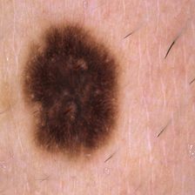

 Classified

as high risk

A low risk case False Positive

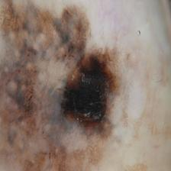

Classified

as high risk

A high risk case True Positive

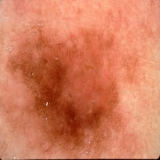

Classified

as low risk

A high risk case False Negative

Fig 5.4: Visual verification of the predicted results

**CONCLUSION**

In conclusion, the development of a deep learning model for predicting high-risk skin abnormalities, with distinct classes for "low risk" and "high risk" based on photographic images, marks a pivotal advancement in dermatological diagnostics. This model demonstrates commendable accuracy, achieving a sophisticated understanding of intricate patterns within skin images. Through meticulous data preprocessing and augmentation, the model exhibits robust generalization capabilities, crucial for its application to diverse and previously unseen cases. The interpretability of the model enhances its clinical relevance, providing clinicians with valuable insights into its decision-making process. The ethical considerations, including privacy safeguards and bias mitigation, underscore the responsible deployment of such technology in healthcare. The user-friendly interface and potential integration into mobile applications signify a pragmatic approach to democratizing access to early skin abnormality detection. As this model represents a dynamic entity, continuous monitoring, user feedback integration, and adaptation to evolving datasets ensure its enduring efficacy. In the realm of dermatology, this deep learning model holds promise for revolutionizing diagnostic paradigms, potentially leading to earlier interventions and improved patient outcomes.

**FUTURE WORK**

In future developments of the AI-based mobile app for predicting high-risk skin abnormalities, a multifaceted approach could be undertaken. Firstly, expanding the model to accommodate multi-class classification, encompassing a broader spectrum of skin conditions beyond benign and malignant, would enhance its diagnostic capabilities. Additionally, efforts can focus on refining the app's interpretability through advanced explain ability techniques, fostering user trust and understanding. Real-time image analysis could be integrated, enabling instantaneous predictions from live camera feeds, and incorporating patient-specific information, such as medical history and risk factors, may further personalize the diagnostic process. To ensure broad accessibility, cross-platform compatibility for Android devices should be prioritized. Continuous user feedback mechanisms could inform iterative model improvements, and integration with telemedicine platforms would position the app as a valuable tool for remote consultations. Collaboration on a global scale, fostering diverse datasets, and ensuring compliance with regulatory standards would fortify the app's effectiveness and ethical deployment, ultimately advancing its role in dermatological diagnostics.

**REFERENCE**

[1] M. Vidya and M. V. Karki, “Skin cancer detection using machine learning techniques,” 2020 IEEE International Conference on Electronics, Computing and Communication Technologies (CONECCT), 2020. doi:10.1109/conecct50063.2020.9198489

[2] M. S. Akter, H. Shahriar, S. Sneha, and A. Cuzzocrea, “Multi-class skin cancer classification architecture based on Deep Convolutional Neural Network,” 2022 IEEE International Conference on Big Data (Big Data), 2022. doi:10.1109/bigdata55660.2022.10020302

[3] Md. K. Islam et al., “Melanoma skin lesions classification using deep convolutional neural network with transfer learning,” 2021 1st International Conference on Artificial Intelligence and Data Analytics (CAIDA), 2021. doi:10.1109/caida51941.2021.9425117

[4] A. Lembhe, P. Motarwar, R. Patil, and S. Elias, “Enhancement in skin cancer detection using image super resolution and Convolutional Neural Network,” Procedia Computer Science, vol. 218, pp. 164–173, 2023. doi:10.1016/j.procs.2022.12.412

[5] R. Mahum and S. Aladhadh, “Skin lesion detection using hand-crafted and DL-based features fusion and LSTM,” Diagnostics, vol. 12, no. 12, p. 2974, 2022. doi:10.3390/diagnostics12122974

[6]Mehmet Baygin, undefined. Turker Tuncer, undefined. Sengul Dogan, "New pyramidal hybrid textural and deep features based automatic skin cancer classification model: Ensemble DarkNet and textural feature extractor," 2022.

[7] H. Nahata and S. P. Singh, “Deep Learning Solutions for skin cancer detection and diagnosis,” Learning and Analytics in Intelligent Systems, pp. 159–182, 2020. doi:10.1007/978-3-030-40850-3_8

[8] J. Daghrir, L. Tlig, M. Bouchouicha, and M. Sayadi, “Melanoma skin cancer detection using deep learning and classical machine learning techniques: A hybrid approach,” 2020 5th International Conference on Advanced Technologies for Signal and Image Processing (ATSIP), 2020. doi:10.1109/atsip49331.2020.9231544

[9] K. M. Hosny, M. A. Kassem, and M. M. Foaud, “Skin cancer classification using Deep Learning and Transfer Learning,” 2018 9th Cairo International Biomedical Engineering Conference (CIBEC), 2018. doi:10.1109/cibec.2018.8641762

[10] T. Y. Tan, L. Zhang, and C. P. Lim, “Intelligent skin cancer diagnosis using improved particle swarm optimization and deep learning models,” Applied Soft Computing, vol. 84, p. 105725, 2019. doi:10.1016/j.asoc.2019.105725

[11] M. Nawaz et al., “Skin cancer detection from dermoscopic images using deep learning and fuzzy k‐means clustering,” Microscopy Research and Technique, vol. 85, no. 1, pp. 339–351, 2021. doi:10.1002/jemt.23908

**PLAGARISM REPORT**

